iSphere for WDSCi 7.0/RDi 8.0+

License

This program and the accompanying materials are made available under the terms of the Common Public License v1.0 which accompanies this distribution, and is available at http://www.eclipse.org/legal/cpl-v10.html

Overview

The following features are provided by iSphere for WDSCi 7.0/RDi 8.0+.

- Message File Editor for editing message descriptions within a message file.
- Binding Directory Editor for editing binding directory entries within a binding directory.
- Compare/Merge Editor for comparing/merging source physical file members.
- An extremely fast search feature for searching source files. Searching a member filter in the Remote Systems Explorer with iSphere Source File Search is about 60 times faster than searching with the original RSE Search.
- An extremely fast search feature for searching message files.
- A spooled file subsystem with the ability to open spooled files in Text, HTML and PDF format.
- LPEX Task Tags for source physical file members.
- RSE object decorator showing the object descriptions in the RSE tree.
- RSE Filter Management to import and export all or single filters.
- Data Area Editor for editing data areas.
- User Space Editor for editing user spaces.
- View to monitor the content of data areas and user spaces.

Change Log 2.6.2 (08.07.2015)

This version requires updating your iSphere library to v2.6.2 in order to fix the “iSphere Source File Search” bug.

- Fixed problem that “iSphere Source File Search” did not return a result when the search arguments were all set to “contains-not”.
- Fixed problem that spooled file transformation cannot be used with V5R3. Now using default conversion instead.

Change Log 2.6.1 (16.06.2015)

- Fixed problem that exporting all RSE filters (option 'Single filter pool' not checked) did not work.

Change Log 2.6.0 (06.06.2015)

This version requires updating your iSphere library to v2.6.0

This version requires V5R4 for restoring the save file.

- Changed build process to produce a V5R4 save file.
- Added iSphere Data Queue Monitor view.
- Added iSphere Message File Compare editor.
- Added option to delete existing objects to the iSphere library uploader.
- Added option to the result view of the iSphere Source File Search to specify the mode (*EDIT/*BROWSE) the Lpex editor is started for when double-clicking a source member.
- Added popup menu to the statements table of the iSphere Source File Search view.
- Added view menu to the iSphere Source File Search view with options for loading and saving search results.
- Added options to the preferences page and the “iSphere Source File Search” and “iSphere Message File Search” views for automatically saving search results when the view is closed.
- Added preferences page for label decorations of the RSE tree.
- Added key bindings (Ctrl+I,M) and (Ctrl+I,S) for the iSphere source file and message file dialogs.
- Added commands to assign key bindings to: “Data Space Editor Designer”, “RSE Filter Management”, “Transfer iSphere Library”, “Open message file search dialog” and “Open source file search dialog”.
- Added menu option “Help” to the iSphere menu.
- Added “Close” button the iSphere Source File Search and Message File Search result views.
- Added option "Copy selected" to the context menu of the iSphere search result views (source file members/message files).
- Added keyboard shortcuts CTRL-A (select all) and CTRL-C (copy) and a context menu to the iSphere Transfer Library dialog to copy the displayed messages to the clipboard for easier error reporting.
- Added I Project label decorator to show the object descriptions in an i Project.
- Added dialog for selecting the filter pool when exporting a search result to a member or object filter.
- Changed the iSphere Compare feature, so that more than two members can be selected for easily comparing members with the same name in different source files.
- Now the iSphere search dialogs show up in the Eclipse “Search” menu.
- Fixed bug, that the decimal data area editor did not allow negative values
- Fixed double print problem when converting a spooled file to TEXT, HTML or PDF.
- Fixed minor page break problem when converting a spooled file to HTML.
- Fixed bug that the character preceding a form feed (FF) was not converted to text, html and pdf when saving or displaying a spooled file.
- Fixed formatting problem in message preview view.
- Fixed problem that the designer repository was not properly saved as UTF-8 stream.
- No dropping an object on a pinned view is rejected.
- Now dropping a data space object is rejected when auto-refresh is on.
- Now properly disabling auto-refresh options when there is no object in a view.
- Removed the need for the QGPL/ISPHERE data area. That data area can be safely deleted, now. We now use the QSZRTVPR API to get the release level of the operating system.
- Added Eclipse update sites:
RDi: http://isphere.sourceforge.net/eclipse/rdi8.0/
WDSCi: http://isphere.sourceforge.net/eclipse/wdsci7.0/
- Added Eclipse update sites for beta version:
RDi: http://isphere.sourceforge.net/beta-version/eclipse/rdi8.0/
WDSCi: http://isphere.sourceforge.net/beta-version/eclipse/wdsci7.0/

Change Log 2.5.2 (11.02.2015)

- Added menu option “Transfer iSphere Library”. Default values are: Library ISPHERE and FTP port number 21. The defaults can be changed on the “iSphere/Library” preference page.
- Improved error logging of FTP transfer.

Change Log 2.5.1 (10.02.2015)
(Internal test release)

- Fixed bug that substitution variables where not properly retrieved by the new IQMHRTVM API.
- Fixed NullPointerException in the iSphere Message File Editor, when using the DEL key to delete message descriptions.
- Fixed ClassCastException in AbstractViewManager when closing views that are not an instance of IPinnableView.

Change Log 2.5.0 (08.02.2015)

This version requires updating your iSphere library to v2.5.0

- Added the iSphere Data Area Editor.
- Added the iSphere User Space Editor.
- Added view for monitoring data areas and user spaces.
- Added the iSphere Data Space Editor Designer for defining the structure of data areas and user spaces.
- Added Italian translation.
- Fixed bug that the message description was not updated in the table viewer on a double-click change event.
- Fixed bug, which dropped newly added messages from the list when the filter had been changed afterwards.
- The length of a message will be displayed in the iSphere Message File Editor.
- Extended the “Search for updates” feature to optionally search for beta versions.
- Now the iSphere Search Pages (CTRL+H) remember the last used connection.
- Changed structure of iSphere zip file so that it can be used as an archived update site.
- iSphere RSE Filter Management with special support for filter pools.
- Added option to remove items from the “iSphere Source File Search” and the “iSphere Message File Search” result views.
- Added option to invert the selection of the “iSphere Source File Search” and the “iSphere Message File Search” result views.
- Added iSphere “Retrieve Message (IQMHRTVM) API” to speed up loading large message files.

Change Log 2.4.0 (12.09.2014)

- New Feature “iSphere RSE Filter Management” to import and export all or single filters.
- New Feature “Search for updates” to search for new iSphere versions when the IDE starts.
- Fixed bug in iSphere Compare/Merge Editor when using the flag “Ignore case”. Whether or not this flag will be set, it will not be considered.
- Fixed bug in iSphere Source File Search. Flags “Include first level text” and “Include second level text” will be provided. In iSphere Source File Search this is wrong and has fixed.

Change Log 2.3.0 (22.08.2014)

- Added option “include 1. level text” to “iSphere Message File Search Page”.
- Added options “Include first level text” and “Include second level text” to “iSphere Message File Search” from the RSE tree.
- Now storing the current values of the “iSphere Message File Search” from the RSE tree.
- Enhanced the iSphere Message File Editor to use a multiline text field instead of a small combo box.
- Added options to the iSphere Message File Editor to filter messages by first and/or second level text.

Change Log 2.2.0 (19.08.2014)

- Fix invalid length property when adding a message description with a *VARY field.
- Fixed iSphere Compare Editor to ignore trailing spaces.
- Added port number for FTP transfer to preferences page.
- Enabled source member compare editor to work on two selected members.
- Added “iSphere Message File Search Page” (CTRL+H)
- Added “iSphere Source File Search Page” (CTRL+H)
- Enhanced “iSphere Message File Search” from the RSE tree to allow logical AND/OR combinations of multiple search strings.
- Enhanced “iSphere Source File Search” from the RSE tree to allow logical AND/OR combinations of multiple search strings.
- Added option to change attributes "Severity" and "Ccsid" of a message description.
- Added RSE object decorator to show the object descriptions in the RSE tree.
- Added view “iSphere Message Description” to show the formatted text of a message description of the RSE tree or “iSphere Message File Editor”.

Change Log 2.1.0 (10.04.2014)

- Changed build process to produce a V5R3 save file.
- Added Dutch translation.

Change Log 2.0.0 (02.04.2014)

- In view “iSphere Source File Search”, which contains the search results, the member description will now be displayed next to the member.
- If you export the search results displayed in view “iSphere Source File Search” to Excel, the output contains now also the column “Member Description”.
- If you export the search results displayed in view “iSphere Message File Search” to Excel, the output contains now also the column “Message File Description”.
- iSphere Source File Search can now run in background. When starting the search a progress window appears. Here you can press the button “Run in Background”.
- iSphere Message File Search can now run in background. When starting the search a progress window appears. Here you can press the button “Run in Background”.
- Deleting spooled files can now run in background. When starting the delete task, a progress window appears. Here you can press the button “Run in Background”.
- When opening a member via the view “iSphere Source File Search” the LPEX editor will be used by default. When you now open a member with type DSPF, MNUDDS or PRTF iSphere asks you to use the LPEX editor, the screen designer or the report designer.
- The search results of iSphere Source File Search can now be exported to a member filter
- The search results of iSphere Message File Search can now be exported to an object filter
- By default spooled files are converted by spooled file transform and workstation customization objects, now.
- The binding directory editor has been changed to let you double-click a binding directory entry for editing.
- The binding directory entry and the message description editor have been changed to remember their size and position.
- Added new “iSphere Task Tags” plugin. Now you can add your own task tags to your source member, e.g. TODO, FIXME, etc.
- Now a list of spooled files based on spooled file filters can be shown in view “Remote System Details” by selecting “Show in Table” in the context menu of the spooled file filter.

Change Log 1.4.2 (23.03.2014)

When opening a spooled file it can occur that the contents of the spooled file will not be displayed. This error has fixed.

Change Log 1.4.1

For the iSphere client the right iSphere library has to be installed on the host. If not, then a window should pop up with a specific message. This window doesn`t pop up. This error has now fixed.

Change Log 1.4.0

- A new spooled file subsystem with the ability to open spooled files in Text, HTML and PDF format.
- The search results of iSphere Source File Search and iSphere Message File Search can be exported now to Excel.

Change Log 1.3.0

- A new extremely fast search feature for searching message files.

Change Log 1.2.2

- When comparing two members with the Compare/Merge Editor and trying to save the left member after changing it an error occurs in RDi 8.5 and RDi 9.0 that the save operation has failed. This has fixed.

Change Log 1.2.0

- A new extremely fast search feature for searching source files.

Change Log 1.1.1

- Making the Binding Directory Editor work for servers which are not running at least V6R1M0.

Change Log 1.1.0

- For the Message File Editor you now can specify to search by the filter case sensitive or not.
- A new Binding Directory Editor for editing binding directory entries within a binding directory is provided.

Instructions for WDSCi 7.0

Download the update site needed for installation

Download the Zip file “iSphere for WDSCi 7.0 (Update Site)” from
https://sourceforge.net/projects/isphere

Unzip the file.

Install iSphere for WDSCi 7.0 (Client Part)

Start WDSCi 7.0. (On Windows Vista or Windows 7 WDSCi has to be started with “Run as administrator”).

Select menu item „Help/Software Updates/Find and Install“.

Select „Search for new features to install“ and click „Next“.

Click „New Locale Site“.

Select the downloaded folder „iSphere for WDSCi 7.0 (Update Site)“ in the target directory.

Click „OK“.

In window „Update sites to visit“ select the iSphere update site. Deselect all other selected update sites.

Click „Finish“.

In window „Search results“ expand all positions.

Click „Next“.

Click „I accept the terms in the license agreement“.

Click „Next“.

If you have installed additional third party Plug-Ins in WDSCi 7.0 - for example Instantations “Windows Builder Pro” -, then it can occur, that in window “Installation” in field “Install Location” an other directory appears, than the one you have defined to install WDSCi 7.0 - for example C:/Programs/IBM/SDPxxx -. If so, then click “Change Location”, select the directory where you have installed WDSCi 7.0 and click “OK”.

Click „Finish“.

The window „Feature Verification“ with the message „You are about to install an unsigned feature” appears. Ignore the message and click „Install All”

The window „Install/Update” with the message „You will need to restart …” appears. Click „Yes”.

Uninstall iSphere for WDSCi 7.0 (Client Part)

Start WDSCi 7.0. (On Windows Vista or Windows 7 WDSCi has to be started with “Run as administrator”).

Select menu item „Help/Software Updates/Manage Configuration“.

Expand the tree on the left side.

Right-click all entries “iSphere” and select “Uninstall”

The window „Uninstall” with the message „Do you want to …” appears. Click „OK”.

The window „Install/Update” with the message „You will need to restart …” appears. Click „Yes”.

After restart the window “Problems” can appear with the message “Could not restore workbench layout”. You can ignore the message. Click OK. For future starts of the IDE, the message will not occur again.

Instructions for RDi 8.0+

Download the update site needed for installation

Download the Zip file “iSphere for RDi 8.0+ (Update Site)” from
https://sourceforge.net/projects/isphere

Unzip the file.

Install iSphere for RDi 8.0+ (Client Part)

Start RDi 8.0+. (On Windows Vista or Windows 7 RDi has to be started with “Run as administrator”).

Select menu item „Help/Install New Software“. The window “Available Software” appears.

Click „Add “. The window “Add Repository” appears.

Click “Local”. The window “File Chooser” appears.

Select the downloaded folder „iSphere for RDi 8.0+ (Update Site)“ in the target directory.

Click „OK“. The iSphere update site appears in window “Available Software”.

Select the iSphere update site. Deselect all other selected update sites.

Click “Next”. The window “Install Details” appears.

Click “Next”. The windows “Review Licenses” appears.

Click “I accept the terms of license agreements”.

Click „Finish“. The window “Installing Software” appears. Don`t cancel the process.

The window “Security Warning” appears. Click “OK”.

The window „Software Updates” with the message „You will need to restart …” appears. Click „Restart Now”.

Uninstall iSphere for RDi 8.0+ (Client Part)

Start RDi 8.0+. (On Windows Vista or Windows 7 RDi has to be started with “Run as administrator”).

Select menu item „Help/Install New Software“.

Click “What is already installed”.

Tick all entries “iSphere” and click “Uninstall”. The window “Uninstall Details” appears.

Click “Finish”.

The window „Software Updates” with the message „You will need to restart …” appears. Click „Restart Now”.

After restart the window “Problems” can appear with the message “Could not restore workbench layout”. You can ignore the message. Click OK. For future starts of the IDE, the message will not occur again.

Instructions for WDSCi 7.0 / RDi 8.0+

Install iSphere (Server Part)

Start WDSCi 7.0 / RDi 8.0+.

Click on “Windows / Preferences”.

Expand the item “iSphere”.

Click on “Library”.

Click on “Transfer iSphere Library”.

The following window appears.

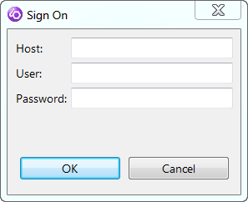

Enter host, user, password and click “OK”.

The following window appears.

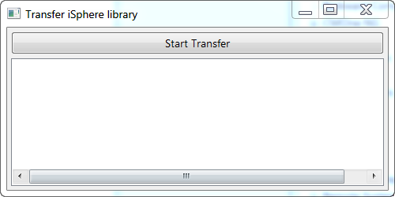

Click “Start Transfer”. The library ISPHERE will be transferred to the host.

Close the window.

Install iSphere (Server Part by hand)

Unzip biz.isphere.core_x.x.x.jar from the iSphere Update Site zip file.

Unzip file ISPHERE from directory /Server of biz.isphere.core_x.x.x.jar.

Create an empty save file in QGPL:

CRTSAVF FILE(QGPL/ISPHERE) TEXT('iSphere')

Start a FTP session and transfer the local ISPHERE file into the ISPHERE save file on your host using binary mode.

Restore library ISPHERE from the save file QGPL/ISPHERE:

RSTLIB SAVLIB(ISPHERE) DEV(*SAVF)
SAVF(QGPL/ISPHERE) RSTLIB(ISPHERE)

Uninstall iSphere (Server Part)

Delete manually library ISPHERE on the server. That`s all.

Message File Editor

The Message File Editor gives you the ability to edit message descriptions within a message file.

To edit the message descriptions of a message file do the following.

- In the Remote Systems Explorer open the context menu for a message file.
- Select menu item “iSphere Message File Editor”.

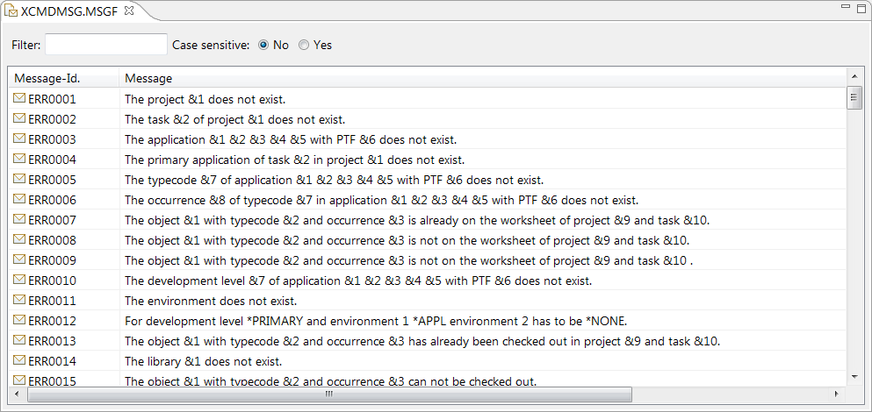

Binding Directory Editor

The Binding Directory Editor gives you the ability to edit binding directory entries within a binding directory.

To edit the binding directory entries of a binding directory do the following.

- In the Remote Systems Explorer open the context menu for a binding directory.
- Select menu item “iSphere Binding Directory Editor”.

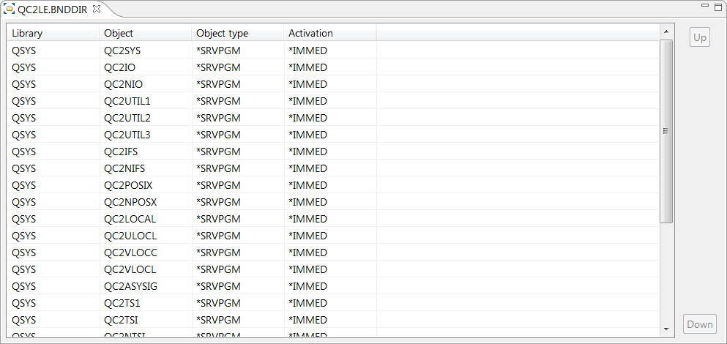

With IBM i V6R1M0 IBM has added the parameter value “Activation” to parameter OBJ of command ADDBNDDIRE. If on a server is not installed at least V6R1M0 you have to execute the following command on this server in order to work with this feature of the iSphere plugin. You have to replace the value VxRxMx with the installed release on this server. For example V5R4M0.

CRTDTAARA DTAARA(QGPL/ISPHERE) TYPE(*CHAR) LEN(6) VALUE('VxRxMx') TEXT('iSphere')

Compare/Merge Editor

The Compare/Merge Editor gives you the ability to compare/merge source physical file members.

To compare/merge source physical file members do the following.

- In the Remote Systems Explorer open the context menu for a source physical file member.
- Select menu item “iSphere Compare Editor”.

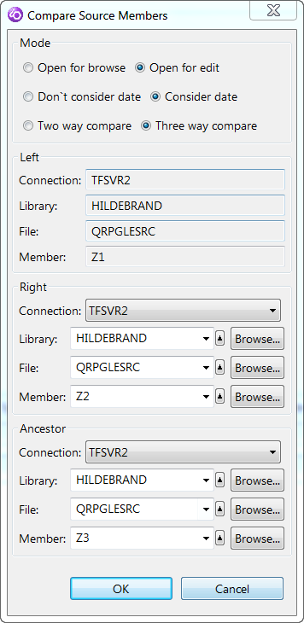

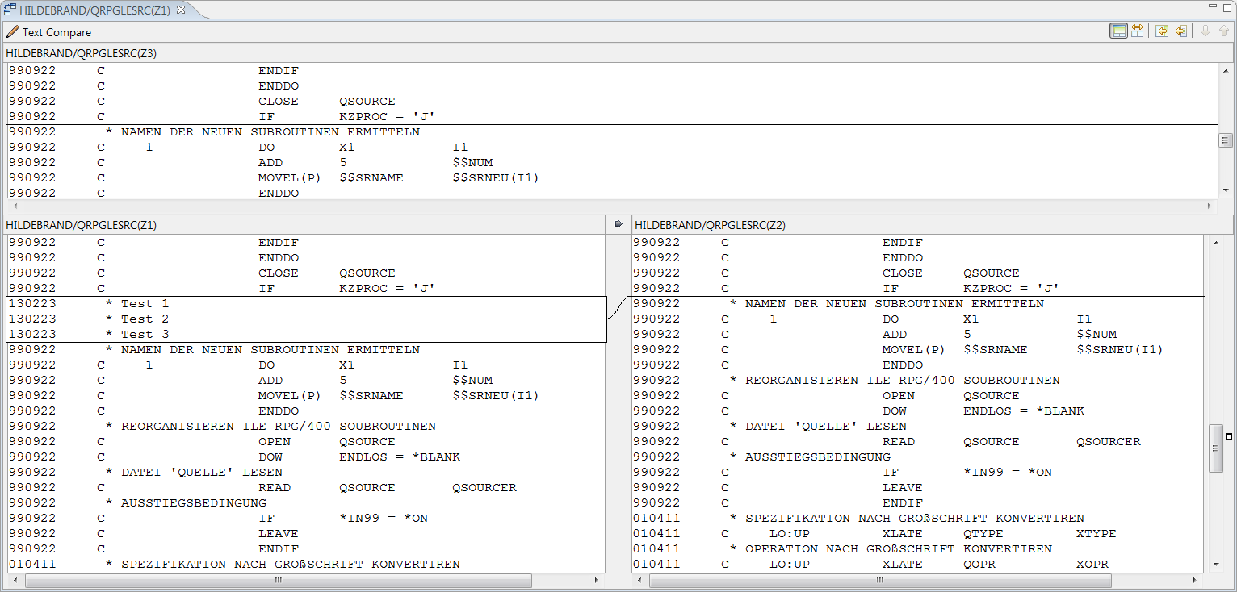

Source File Search

The Source File Search feature gives you the ability to search extremely fast source files on a server. Searching a member filter in the Remote Systems Explorer with iSphere Source File Search is about 60 times faster than searching with the original RSE Search. The first time after an IPL using iSphere Source File Search can take a little bit more time. But after the second time you should see the improvement.

To search source files on a server do the following.

- In the Remote Systems Explorer open the context menu for a library filter, a member filter or a source physical file member.
- Select menu item “iSphere Source File Search”.
- Enter the search string, start and end column of the member to search and if the search is case sensitive or not and click “OK”.

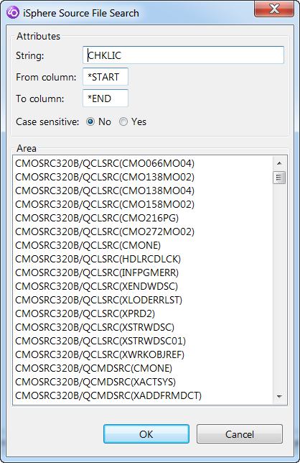

- The view “iSphere Source File Search” with the search results appear.

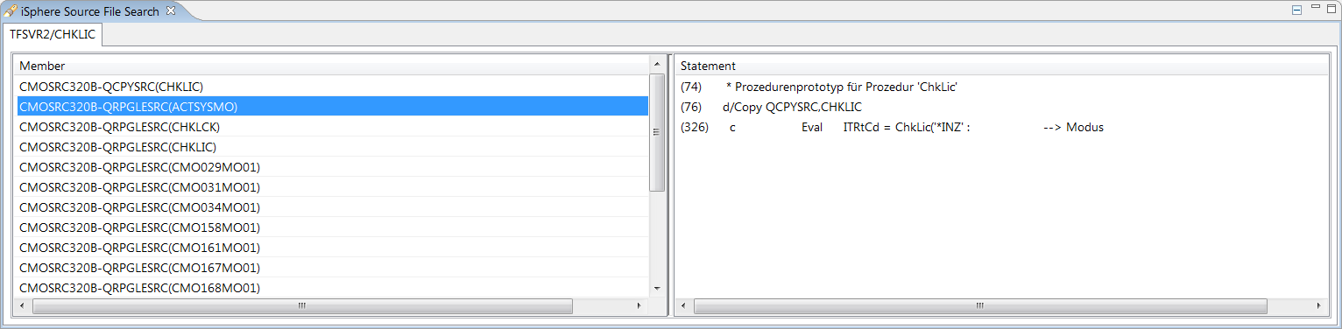

Click on the left side on a member and a preview of the statements containing the search string within the member appears.

Double click on the left side on a member and the LPEX editor will be opened.

Right click on the left side on a member and the context menu appears. Select “Open editor” to open the LPEX editor.

Double click on the right side on a statement and the LPEX editor will be opened. The source will be positioned on the selected statement.

Click on icon in the upper right corner of the view to remove the tab from the view.

Click on icon in the upper right corner of the view to export the search results to Excel.

Message File Search

The Message File Search feature gives you the ability to search extremely fast message files on a server. The first time after an IPL using iSphere Message File Search can take a little bit more time. But after the second time you should see the improvement.

To search message files on a server do the following.

- In the Remote Systems Explorer open the context menu for a library filter, a object filter or a message file.
- Select menu item “iSphere Message File Search”.
- Enter the search string, start and end column of the message file to search and if the search is case sensitive or not and click “OK”.

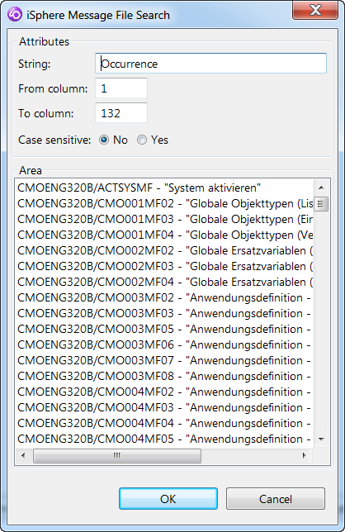

- The view “iSphere Message File Search” with the search results appear.

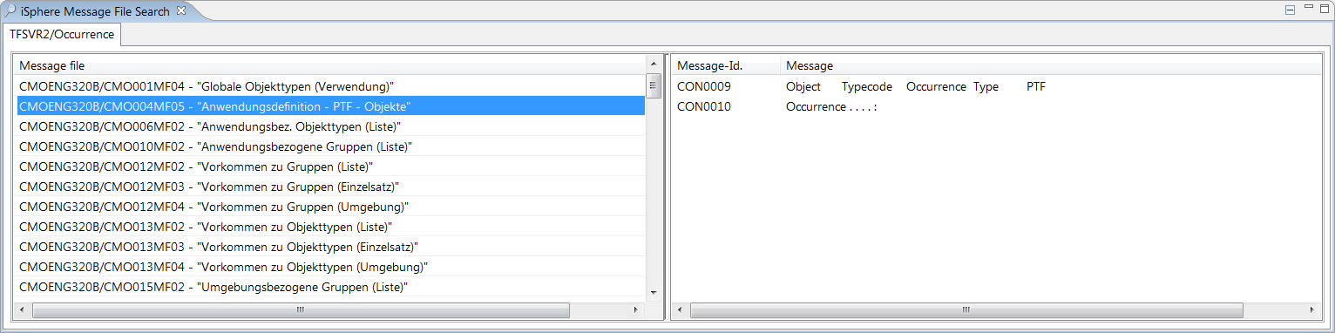

Click on the left side on a message file and a preview of the messages containing the search string within the message file appears.

Double click on the left side on a message file and the Message File Editor will be opened.

Right click on the left side on a message file and the context menu appears. Select “Open editor” to open the Message File Editor.

Double click on the right side on a message and a dialog appears to change the message.

Click on icon in the upper right corner of the view to remove the tab from the view.

Click on icon in the upper right corner of the view to export the search results to Excel.

Spooled File Subsystem

With the iSphere Spooled File Subsystem it is possible to maintain the spooled files on an IBM i server. Here are the features.

- Maintaining spooled files filter with filter criteria’s user, output queue, user data and form type to show the spooled files in the RSE Tree View
- Hold a spooled file
- Release a spooled file
- Change spooled file attributes
- Reply a message for a spooled file
- Display spooled files attributes in the eclipse properties view
- Open a spooled file in Text, HTML and PDF Format
- Save a spooled file in Text, HTML and PDF Format
- Integrate your own conversion tools for conversion of spooled files to Text, HTML and PDF. (There are lot of vendors providing tools for spooled file conversion out there)
- For opened spool files in every format the CRTL+F key is active for searching the spooled file
- For opened spool files in every format the CRTL+P key is active for printing the spooled file

Select “Window/Preferences”. Click in the tree view on the left side on the plus symbol prior to “iSphere”. Click on “Spooled Files”.

Here you can specify in which format a spooled file will be opened when you double click on a spooled file in the spooled files subsystem.

You can also integrate your own conversion tools for conversion of spooled files to Text, HTML and PDF. In field “Library” enter the library name which contains the conversion command. In field “command” enter the conversion command. Use the substitution variables for the specific parameters of the command.

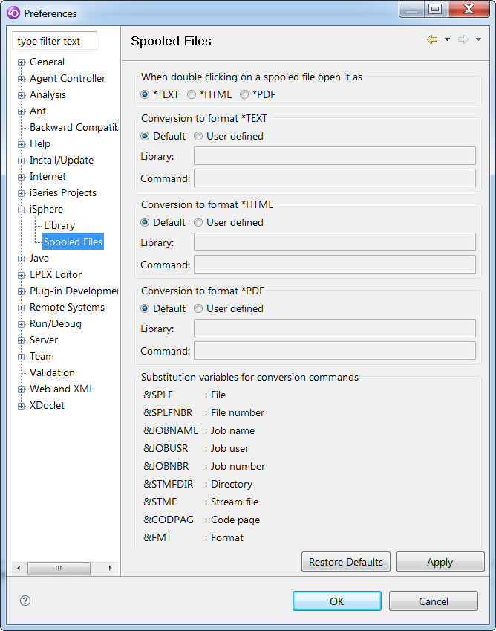

In Remote Systems Explorer you can see now the new iSphere Spooled File Subsystem. Here you can create Spooled File Filter for the spooled files you want to see. When you open the context menu for a spooled file you can select the actions.

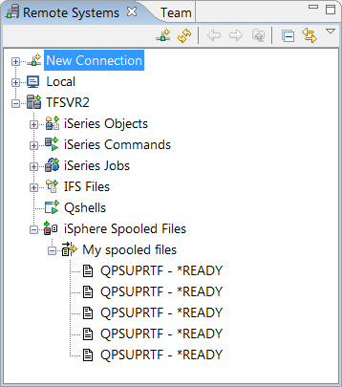

RSE Object Decorator

The RSE object decorator shows the descriptive text of objects and source members:

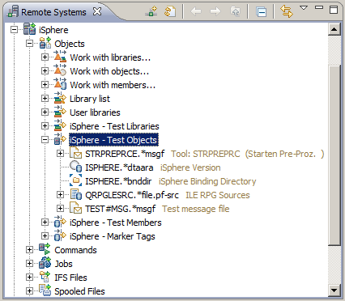

Go to Window → Preferences → General → Appearance → Label Decorations to enable or disable the decorator:

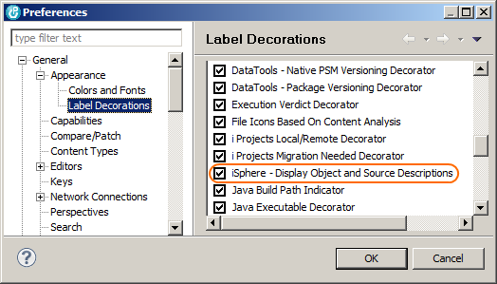

RSE Filter Management

With iSphere RSE Filter Management you can export single or all filters from your workspace to a repository (XML File). You can import single or all filters from a repository to your workspace. The filters in the workspace and in the repository will be provided in four separate areas.

- Filters only in workspace.
- Filters only in repository.
- Filters in workspace and in repository with different type or filter string.
- Filters in workspace and in repository with equal type and filter string.

In the areas you can define actions for the filters you want to perform. The actions are.

- Push to workspace.
- Push to repository.
- Delete from workspace.
- Delete from repository.
- Delete from both.

After defining all actions for the specific filters you have to perform the actions. The changes will be applied.

There are several scenarios you might find this new feature useful.

- Your workspace is corrupted and you have the need to create a new one. In this case you can export your filters from the old workspace and import them into the new one.
- You want to share your filters with your colleagues.
- You have RDi installed on a computer in your office and at home and want to synchronize your filters.

To open the iSphere RSE Filter Management dialog click on the icon in the upper right corner of the view Remote Systems.

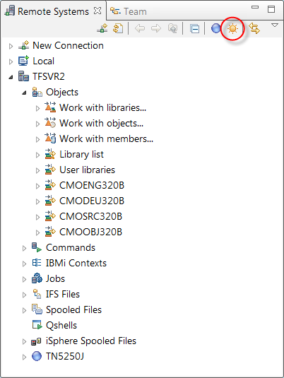

Specify the filter pool of your workspace and the repository. If the repository you specify does not exist you will be ask for creation.

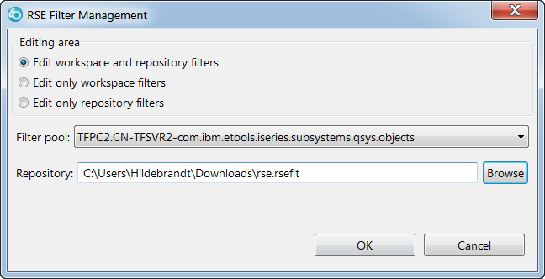

Choose first the action for the filters. After this click “Perform actions”. The changes will be applied to your workspace and to your repository.

